CURRICULUM VITAE

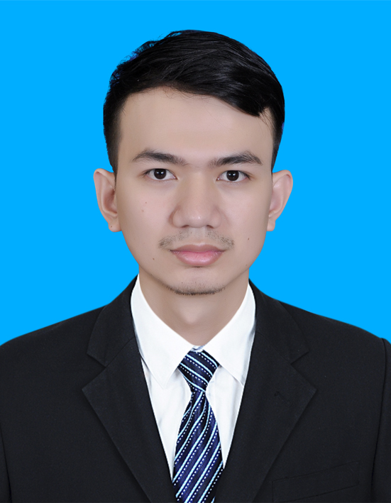
Full Name : Houy Lykheang
Last Name : Houy
First Name : Lykheang
Current Address : St 218, Sangkat Boeung Salang , Khan Toul Kouk, Phnom Penh , Kingdom of Cambodia
Phone Number : 077 766 895
Email Address : houylykheang@gmail.com

PERSONAL DETAILS

Sex : Male
Marital Status : Single
Date of Birth : 18 March 1996
Place of Birth : Prey Slerk, Chhbarmon, Kompong Spue, Kingdom of Cambodia
Nationality : Cambodian
Religion : Buddhism

EDUCATION AND QUALIFICATION

2001 - 2007 : Som Buo Primary School
2007 - 2010 : Chhay Chhob Secondary School
2010 - 2013 : Bun Rany Hunsen Phnom Srouch High School (Certificate)
2015 - Present : Studying International Relations at Pannasastra University of Cambodia (PUC)

OTHER SKILLS

Computer skills : Microsoft Word, Microsoft Excel, Power Point

LANGUAGES

Khmer : Mother tongue
English : Very good (Speaking, Writing, Listening, Reading)

INTERESTS

Reading books, Watching News, Listening to music, International Politic

HOBBIES
Watching TV
Doing Exercises
Listening To Music
Going To Hometown
Reading Books
Reading News

